**ASSIGNMENT 2 : RISHABH GAUR**

Q1. Write a script to convert:-

1. int to str
2. float to str
3. str to int
4. str to float

**output:-** 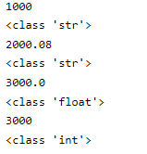

Q2. Differentiate between /, // and %.

**Answer:-**  **/** is used for division. Eg:-

**Output:-** 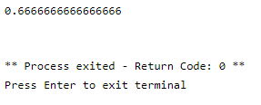

**//** is used for float division. Eg:-

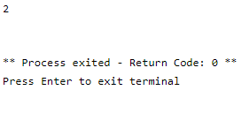

**%**  is used for finding the modulus. Eg:-

**Output:-** 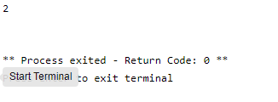

Q3. Display the sequences using for loop:-

1. 5 10 15 20 …………. 100
2. -25 -24 -23………… -5

**Output:-** 0

1

2

3

4

5

6

7

8

9

10

11

12

13

14

15

16

17

18

19

20

21

22

23

24

25

26

27

28

29

30

31

32

33

34

35

36

37

38

39

40

41

42

43

44

45

46

47

48

49

50

51

52

53

54

55

56

57

58

59

60

61

62

63

64

65

66

67

68

69

70

71

72

73

74

75

76

77

78

79

80

81

82

83

84

85

86

87

88

89

90

91

92

93

94

95

96

97

98

99

100

** Process exited - Return Code: 0 **\*\***

2nd sequence:- -25

-24

-23

-22

-21

-20

-19

-18

-17

-16

-15

-14

-13

-12

-11

-10

-9

-8

-7

-6

-5



** Process exited - Return Code: 0 **

Q4. Write a script to input two numbers and display their sum.

Output:- Enter the 1st number

2

Enter the 2nd number

2

4

** Process exited - Return Code: 0 **



Q5. Write a script to input a character from user; display that character along with its ASCII value.

**Output:-**

enter any character

a

97



Q6. Write a script to input a number from user and check whether:-

1. It is even or odd.
2. It is positive or negative.

**Output:-**

Enter any number to test if it is odd or even

3

The number is odd

** Process exited - Return Code: 0 **



**Output:-**

Enter any number to test if it is positive or negative

-1

The number is negative

** Process exited - Return Code: 0 **



Q7. Write a script to input marks from user and display grade:-

1. 90-100 : A
2. 80-89 :B
3. 60-79 : C
4. Less than 59:D

**Output:-**

enter the marks

64

C grade

** Process exited - Return Code: 0 **



Q8. Write a script to print sum and average of first n numbers starting from 1.

**Output:-**  sum of first n numbers:-

Enter a number

6

21

** Process exited - Return Code: 0 **



Average of first n numbers:-

**Output:-**

Enter a number

8

36

18

** Process exited - Return Code: 0 **



Q9. Write a script to input a number and find its factorial.

**Output**:-

Enter a number:

4

The factorial of 4 is 24

** Process exited - Return Code: 0 **



Q10. Write a script to find greatest of three numbers entered by user.

Output:-

Enter 1st number

6

Enter 2nd number

7

Enter 3rd number

8

3rd number is greatest.

** Process exited - Return Code: 0 **



Q11. Write a script to input a number from user and display its multiplication table.

**Output**:-

enter a number

8

8 * 0 = 0

8 * 1 = 8

8 * 2 = 16

8 * 3 = 24

8 * 4 = 32

8 * 5 = 40

8 * 6 = 48

8 * 7 = 56

8 * 8 = 64

8 * 9 = 72

8 * 10 = 80

** Process exited - Return Code: 0 ** 

Q12. Write a script to print first ASCII values.

**Output:-**





Q13. Write a script to print following patterns:-

**Output:-**

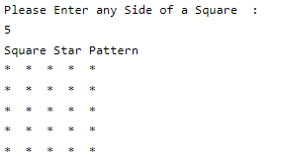

**Output:-**

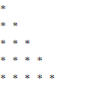

**Output:-**

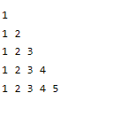

**Output:-**

